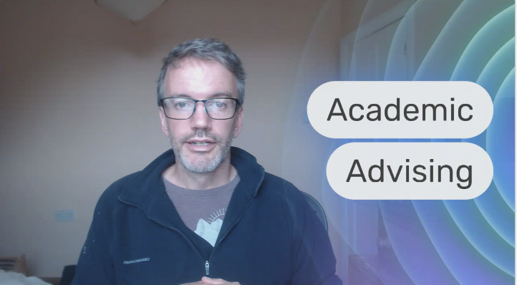

Hello,

New in 2023, the Institute of Dentistry is implementing an Academic Advising programme for all BSc and BDS students.

I explain briefly what is involved in this video. https://prezi.com/v/view/YpfVNnlnbetVLI8QvPh2/

More details about your Academic Advisor will follow.

All the best,

Dominic

