Balanced scorecard

The Balanced Scorecard (Kaplan and Norton, 1992) is a strategic approach and performance management system enabling organisations to translate a company's vision and strategy into implementation, working from 4 perspectives:

- Financial
- Customer
- Business processes
- Learning and growth.

It was developed to overcome the limitations of traditional financial reporting systems as a means of assessing the health and future prospects of the organisation. The Balanced Scorecard (BSc) framework is summarised in the diagram below:

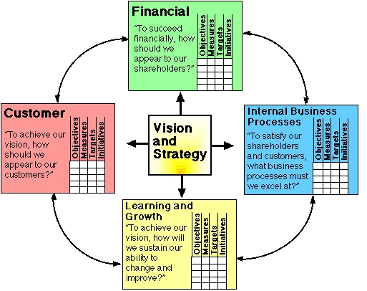

- The financial perspective includes measures such as operating income, return on capital employed and economic value added.
- Customer perspective would take in customer satisfaction, retention and market share in target segments
- Business processes refers to cost, throughput and quality in relation to functions like purchasing, production and order fulfilment
- Learning and growth might cover employee satisfaction, retention, skill sets, etc.

The BSc framework translates organisational strategy into these four perspectives, simultaneously seeking the right balance between the opposing forces between:
- Internal and external measures
- Objective and subjective measures
- Performance results and drivers of future results.

In addition, the four perspectives are linked:
- Learning and growth lead to better business processes…
- …and in turn to increased value to the customer…
- …and on to improved financial performance.

Implementing strategy with the Balanced Scorecard
Although originally conceived as a performance measurement system, in fact BSc is widely used a management system for implementing strategy, typically in the following stages:
- Clarifying strategy – translating strategic objectives into quantifiable measures, clarifying the understanding of the management team, and developing coherent consensus
- Communicating strategic objectives - using BSc to translate strategic objectives into operational plans and communicate the strategy throughout the organisation
- Planning, setting targets and aligning activity – ambitious but achievable targets are set for each perspective, and initiatives developed to establish concerted efforts to achieve targets
- Strategic feedback and learning – the top team receives feedback both on the execution and success of their strategy.

Four implementation issues

Experience with the Balanced Scorecard has highlighted a number of factors critical to successful implementation. Among these are:
- Getting the measures right. It is essential to define measures which:
  - Are valid and meaningful to those responsible for meeting them
  - Can realistically be monitored
  - Will help determine future action
- Commitment from the top. In theory, Balanced Scorecards can work if implemented either bottom-up or top-down. In practice, if the most senior people in the organisation don't pay attention to the new measures, success is unlikely.
- Accountability. Balanced Scorecards, or any other measurement scheme, will be pointless if people are not held accountable for meeting their commitments.
- The Balanced Scorecard process. This can focus on broadcasting the views of management, and then holding people accountable for what management has determined is important. Or, it can be viewed as initiating a profound and ongoing process of organisational change.

The table on the following page lists several measures commonly used for the four perspectives of a balanced scorecard. Any organization implementing BSc will obviously customize measures to its own goals and culture.

Financial | Customer | Business Process | Learning & Growth
Return on investment (ROI), Economic value added  Return on capital employed  Profitability  Sales growth  Margin growth  Revenue growth and mix  Gross sales vs. competition  Gross profit vs. potential  Sales growth by segment  Percentage revenue from new product, service, and customers  Share of targeted customers and accounts  Cross selling  Percentage revenues from new applications  Customer and product line profitability  Percentage unprofitable customers  Cost reduction  Revenue per employee  Cost vs. competitors  Cost reduction rates  Indirect expenses (% of sales)  Productivity improvement  Asset utilisation  Investment strategy  Cost to spend ratios  Cash flow  Net margin rank (vs. competition)  Operating margin | Customer acquisition (new customers, total sales to new customers, contacts with targeted sponsors)  Customer satisfaction (product attributes, image, service speed, helpfulness, would recommend)  Customer retention/loyalty (annual purchase growth)  Market share (number of customers, spend, unit volume sold, account share  Customer profitability | Quality  Timing, response time (on time delivery defined by customer), wait time, production cycle time  Information accuracy  Cost  Innovation, new product introductions  Defect rates (parts/million), waste, scrap, rework  Yield (ratio of items produced to items entering the process) | Employee satisfaction  Involvement with decisions  Recognition for a good job  Information system availability  Access to information to do job well  Encouragement for creativity and initiative  Overall satisfaction with organization  Employee motivation (suggestions per employee, suggestions implemented)  Personal goals alignment  Employee retention (percentage of staff turnover)  Employee productivity (revenue per employee, strategic job coverage ratio)

