Queen Mary University of London

ILM Development Programme

Managing improvement

Workbook
INTRODUCTION
This workbook supports achievement of the ILM Level 5 Management and Leadership Unit M5.02, Managing Improvement. It should be used in conjunction with the two half-day workshops on this topic, and is complemented by additional handouts which will be provided during these sessions and available on QMplus.

If you are working towards an ILM qualification, the ILM specification on page 3 will be helpful: it sets out the assessment requirements for this Unit, and gives an indication of the areas where you would be expected to demonstrate some knowledge.

Assignment briefs connected with this Unit will be provided by CAPD Advisers.

CONTENTS
ILM SPECIFICATION 3
Quality management 4
Brief history of quality improvement 5
Current UK quality standards 7
Measuring quality 8
Seven quality control tools 9
Kaizen 13
Lean 15
Introducing continuous improvement processes 19
Six sigma 21
Moments of truth 24
A model for improvement 25
Process mapping and analysis 28
Empowerment 30
Employee engagement 32
Empowerment in teams 35

UNIT SPECIFICATION
Title: |  | Managing improvement (M5.02)  Level 5; Credit Value 3; Guided Learning Hours 8
Learning outcomes |  |  | Assessment criteria
- Understand the effectiveness of the organisation and own ability to manage and improve quality to meet customer requirements |  |  | 1.1 Critically assess the organisation’s effectiveness in managing quality to meet or exceed customer requirements  1.2 Evaluate own ability to manage quality to meet or exceed customer requirements
- Be able to plan and implement projects to meet, and if possible exceed, customer requirements |  |  | 2.1 Develop an improvement plan that is designed to meet and, if possible, exceed customer requirements  2.2 Implement improvement plans designed to meet or exceed customer requirements
Indicative coverage
1 | - Quality and customers; quality assurance, quality control and quality auditing  - Quality systems such as BSI, ISO and IiP (benefits and accreditation)  - Total Quality Management  - Tools for maintaining quality, such as records and, where relevant to organisation, the use of statistics  - Conformance and development and practical steps to improve quality  - The costs of quality (positive and negative aspects)  - Concept of internal and external customers and their importance as the focus of the organisation’s activities  - Methods of identifying potential customers  - Methods of identifying customer requirements and monitoring customer satisfaction  - Benchmarking service standards  - Techniques of work and improvement planning to meet customer requirements, such as specifications and service standards, scheduling, and logistics
2 | - Scoping an improvement plan to identify and prioritise areas for improvement, define success criteria and set targets for improvement to meet customer requirements  - Developing and implementing an improvement plan
Quality management

Quality in organisations is related to meeting or exceeding customer satisfaction and requirements. In order to achieve quality, an organisation needs to find out what the customer wants and then meet those requirements.

But quality does not just happen, it has to be managed. Everyone in the organisation has to be involved, and their work must be planned, monitored, measured and controlled.

Total quality
Total quality is a concept which embraces everything an organisation does to deliver high value and high levels of satisfaction to its customers. It implies the use of a disciplined, structured and all-inclusive approach to quality management.

The four basic principles of total quality are:

- Customer satisfaction – the only real measure of the quality of a product or service is the extent to which it delivers customer satisfaction.

- Continuous improvement – creating an environment in which all employees contribute to improving performance and quality so as to reach higher standards in every part of the organisation.

- The significance of internal customers – the ultimate goal of complete customer satisfaction can only be guaranteed if attention is paid to quality in all the transactions and process which take place within an organisation.

- All all-embracing approach – all employees in the organisation need to be involved all of the time in meeting all customer requirements.

A total quality approach is a systematic way of ensuring that all activities within an organisation happen exactly as they have been planned in order to meet the defined needs of customer.

The philosophy is about getting commitment to quality. Total quality can be described as an attitude of mind which leads to appropriate behaviour and actions. But this change in attitude can only develop from a commitment and continuous reinforcement of a quality programme from top management and down through all other management levels.

Brief history of quality improvement

Much of the thinking behind quality management and improvement is based on the work of three principal quality gurus: Deming, Juran and Crosby.

W. Edwards Deming
Deming believed that competitiveness depends upon customer satisfaction which is created by a combination of responsiveness to customers’ views and needs, and the continuous improvement of products or services. Furthermore, in order to remain competitive, organisations must constantly seek out ways of improving their operational systems and the customer appeal of their products or services.
Plan
(strategy, goals, targets)

Do
(take operational action)

Act
(take corrective action)

Check
(measure)

J.M. Juran
Juran published “The Quality Control Handbook” in 1950 which became the standard reference book on quality world-wide. Juran developed his quality philosophy around his “quality trilogy”.

 | - Identify who are the customers
 | - Determine the needs of those customers
Quality Planning | - Translate those needs into our language
 | - Develop a product that can respond to those needs
 | - Optimise the product features so as to meet our needs and customer needs
Quality Improvement | - Develop a process which is able to produce the product
 | - Optimise the process
Quality Control | - Prove that the process can produce the product under operating conditions with minimal inspection
 | - Transfer the process to Operations

Both Juran and Deming stressed the need to involve people throughout the organisation in quality improvement, but in particular that most quality issues are down to management dealing with systems. The emphasis is on getting the correct rather than blaming failure on operator error. Juran particularly emphasised the use of quality teams and training them in measurement and problem solving.

Philip B Crosby
Crosby also focused on using systems and processes to manage quality, believing that by setting up processes that are designed to prevent errors, and by having people trained and motivated to operate them as designed, not only will quality improve, but the costs of production will be reduced.

Like Juran, Crosby’s quality programme was targeted at the management team as a whole and not just quality control specialists. Crosby's Quality Improvement Process is based upon the “4 absolutes of quality”.

- Quality is defined as conformance to requirements, not as 'goodness' nor 'elegance'.
- The system for causing quality is prevention, not appraisal.
- The performance standard must be Zero Defects, not 'that's close enough'.
- The measurement of quality is the Price of Non-conformance, not indices.

The Fourteen Steps to Quality Improvement are the way that the Quality Improvement Process is implemented in an organisation.

- Make it clear that management is committed to quality.
- Form quality improvement teams with senior representatives from each department.
- Measure processes to determine where current and potential quality problems lie.
- Evaluate the cost of quality and explain its use as a management tool.
- Raise the quality awareness and personal concern of all employees.
- Take actions to correct problems identified through previous steps.
- Establish progress monitoring for the improvement process.
- Train supervisors to actively carry out their part of the quality improvement programme.
- Hold a Zero Defects Day to let everyone realise that there has been a change and to reaffirm management commitment.
- Encourage individuals to establish improvement goals for themselves and their groups.
- Encourage employees to communicate to management the obstacles they face in attaining their improvement goals.
- Recognise and appreciate those who participate.
- Establish quality councils to communicate on a regular basis.
- Do it all over again to emphasise that the quality improvement programme never ends.
Current UK quality standards

Quality standards are helpful in improving quality within an organisation. They provide a set of principles – a template or framework which provides the basis for developing and measuring the effectiveness of a quality system.

Documented and accredited quality systems have external and internal advantages. They are a useful marketing tool, raising the profile and image of the organisation, and they provide reassurance for customers and stakeholders that there is a concern for quality and that certain standards are being met. They also have internal advantages in making sure that the organisation is managed efficiently and effectively.

ISO 9000 series | The International Standards Organisation (ISO) provides a framework by which an organisation can set up, implement and monitor quality systems in a structure way.  The aims of the ISO 9000 series is to enable organisations to demonstrate their commitment to achieving customer satisfaction by preventing problems in the products or services they produce at all stages from design to delivery.  The ISO 9000 series is most directly applicable to manufacturing operations.
Investors in People | A national quality standard that sets a level of good practice for improving an organisation’s performance through developing and training its people.  The essential point of meeting the Investors in People Standard is to achieve the organisation’s objectives of raising its level of performance and improving its competitiveness.
Chartermark | Chartermark is a standard open to the public sector, focusing on the continuous improvement of customer service
Business Excellence Model | The UK Business Excellence Model is applied as a way of promoting continuous improvement. It aims to give people a better working environment and provide customers with the best possible value and quality.  The BEM is the first standard to adopt a holistic approach, examining the organisation’s deployment of all its resources: physical, human, financial and even intellectual.
Six Sigma | Sigma is a statistical term used in the measurement of how far a given process deviates from perfection. The idea is that, if you can measure the number of defects there are in a process, you can then systematically attempt to eliminate them to get as close to zero defects as possible.

Measuring quality
The process of managing quality aims to ensure that everyone is involved and committed to the continuous improvement of quality standards and to meeting and exceeding customers expectations. But it is necessary to be explicit about the standards of quality required, and it is equally important to measure and monitor quality performance against these standards. Only by doing this is it possible to identify where corrective action is required.

Comparison of outputs and actions against standards
If standards, targets or indicators – e.g. the time taken to respond to a telephone call – have been established, results can be measured against them.
Inspection
Inspection of the finished product to establish the degree to which it conforms to specification. However, this is an “after-the-event” analysis which does not address why things have gone wrong and what has gone wrong.

Statistical quality control
Statistical quality control uses sampling techniques and statistical analysis to ensure that during design, manufacturing and servicing, work is carried out and material used within the specified limits required to produce the desired standards of quality, performance and reliability. This method identifies problems before they arise so that preventive rather than corrective actions can be taken.

Benchmarking
Benchmarking aims to establish ‘best practice’ by making inter-firm comparisons. Best practice is expressed in terms of what comparable firms are achieving in the shape of quality standards.

Quality standards
The successful achievement of a quality standard, such as Investors in People or Chartermark, confirm that certain standards within the organisation are being met. Many standards require organisations to be re-assessed at differing intervals, thus ensuring that continuous improvement and strong commitment to quality exists.

Customer service surveys
Surveys can be carried out to establish the reactions and opinions of customers to the company’s products or services. These can take the form of direct enquiries after the event or more regular surveys.

Internal surveys
Internal surveys can be conducted of the level of service provided by departments to their internal customers within the organisation. Employee-attitude surveys can be used to assess how quality is regarded, and what people are doing about it.

Seven quality control tools
There is general agreement on the utility of seven quality control tools. Two of fathers of total quality management (Deming and Ishikawa) recommend that the seven tools be utilized to ensure that all attempts at process improvement include:
- Discovery
- Analysis
- Improvement
- Monitoring
- Implementation
- Verification

Checksheet
The function of a checksheet is to present information in an efficient, graphical format. This may be accomplished with a simple listing of items. However, the utility of the checksheet may be significantly enhanced, in some instances, by incorporating a depiction of the system under analysis into the form.

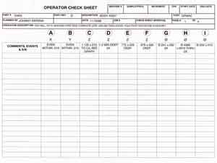

Pareto chart
Pareto charts can be used to identify those factors that have the greatest cumulative effect on the system, and thus screen out the less significant factors in an analysis. Ideally, this allows the user to focus attention on a few important factors in a process.

They are created by plotting the cumulative frequencies of the relative frequency data (event count data), in descending order. When this is done, the most essential factors for the analysis are graphically apparent, and in an orderly format.

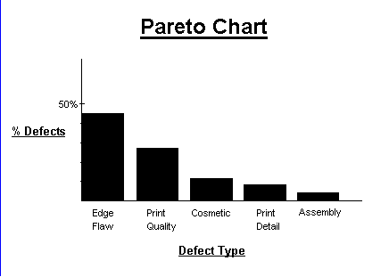

Flowchart
Flowcharts are pictorial representations of a process. By breaking the process down into its constituent steps, flowcharts can be useful in identifying where errors are likely to be found in the system.

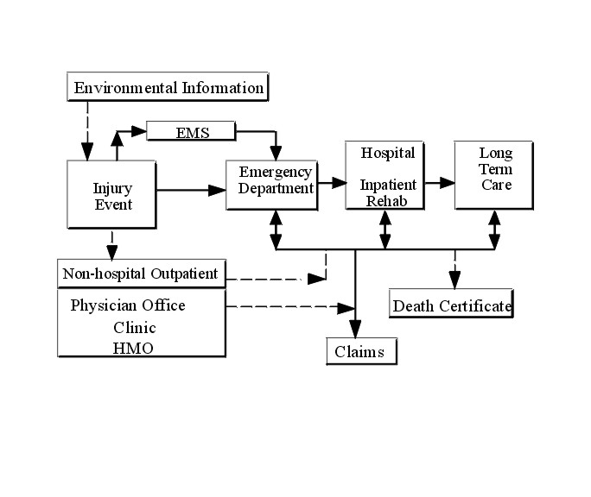

Histogram
Histograms provide a simple, graphical view of accumulated data, including its dispersion and central tendency. In addition to the ease with which they can be constructed, histograms provide the easiest way to evaluate the distribution of data.

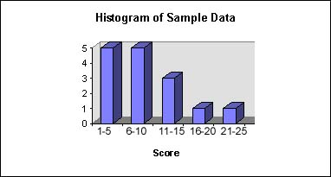

Cause and effect diagram
This tool, also called an Ishikawa diagram (or fish bone diagram), is used to associate multiple possible causes with a single effect. Thus, given a particular effect, the diagram is constructed to identify and organize possible causes for it.

The primary branch represents the effect (the quality characteristic that is intended to be improved and controlled) and is typically labelled on the right side of the diagram. Each major branch of the diagram corresponds to a major cause (or class of causes) that directly relates to the effect. Minor branches correspond to more detailed causal factors. This type of diagram is useful in any analysis, as it illustrates the relationship between cause and effect in a rational manner.

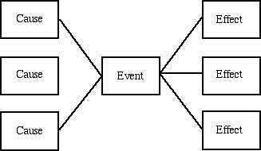

Scatter diagram
Scatter diagrams are graphical tools that attempt to depict the influence that one variable has on another. A common diagram of this type usually displays points representing the observed value of one variable corresponding to the value of another variable

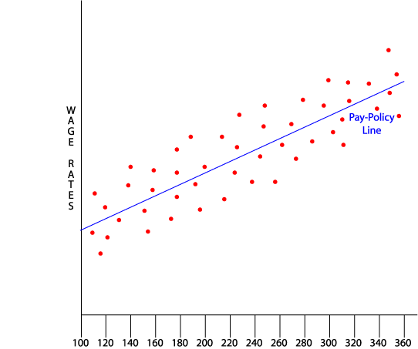

Control chart
The control chart is the fundamental tool of statistical process control, as it indicates the range of variability that is built into a system. Thus, it helps determine whether or not a process is operating consistently or if a special cause has occurred to change the process mean or variance.

The bounds of the control chart are marked by upper and lower control limits that are calculated by applying statistical formulas to data from the process. Data points that fall outside these bounds represent variations due to special causes, which can typically be found and eliminated. On the other hand, improvements in common cause variation require fundamental changes in the process.

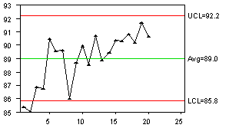

Kaizen
Adopting Kaizen involves the creation of a culture of sustained continuous improvement focusing on eliminating waste in all systems and processes of an organisation. There are two essential elements that make up Kaizen:
- Improvement/change for the better
- Ongoing/continuity.

A system/culture that lacks either of these is not true Kaizen. Thus, maintaining existing ways of working (good though they may be) lacks the essential 'improvement' element, though it ensures continuity. Similarly, 'breakthrough' improvement, not backed up by effective ongoing improvement, lacks the element of continuity. Kaizen should contain both elements. Kaizen is not consistent with the saying "If it ain't broke, don't fix it".

Kaizen achieves its effects by working through people. All are expected to be involved. Managers, for example, are expected to spend about half their time on improving what they (and those for whom they are responsible) do.

Kaizen recognises that improvements can be small or large. Many small improvements can make a big change - so Kaizen works at a detailed level.

The principles/approach behind Kaizen are:
1. Discard conventional fixed ideas.
2. Think of how to do it, not why it cannot be done.
3. Do not make excuses. Start by questioning current practices.
4. Do not seek perfection. Do it right away even if it will only achieve 50% of
target.
5. If you make a mistake, correct it right away.
6. Throw wisdom at a problem, not money.
7. Ask 'WHY?" five times and seek root causes.
8. Seek the wisdom of ten people rather than the knowledge of one.
9. Don't ask workers to leave their brains at the factory gate.

Kaizen is thus a (relatively) low cost, simple, team-based approach
- Teams are trained in the techniques and tools of Kaizen
- Teams then brainstorm improvement ideas and vote on them for priority action.
- Teams then create an action/implementation plan which is submitted to management for approval.
- If it is approved, the team then sets about implementation (with professional help if appropriate).
- The team then meets weekly to review progress, identify/overcome barriers, celebrate successes, and document the resulting changed processes

Evaluation
If an improvement process is to progress, it is necessary to evaluate it at regular intervals. The progress can be measured and demonstrated in terms of:
- Changes in behaviour and attitude
- Reduced industrial relations conflicts
- Ease of cross-departmental communications
- Ease of implementing change
- Improvements in the key operational and business performance indicators
- Reduction in customer complaints
- Reduction in error rates
- Cost savings

The degree to which quality improvement projects are aligned with the company’s articulated strategies, polices and guidelines.
Lean principles

Lean is an improvement approach to improve flow and eliminate waste that was developed by Toyota. Lean is basically about getting the right things to the right place, at the right time, in the right quantities, while minimising waste and being flexible and open to change.

Lean brings into many industries, including healthcare, new concepts, tools and methods that have been effectively utilised to improve process flow. Tools that address workplace organisation, standardisation, visual control and elimination of non-value added steps are applied to improve flow, eliminate waste and exceed customer expectations.

Although most people recognise the roots of Lean thinking in the Toyota production system (Monden, 1983), there has been considerable development of the concept over time. Womack and Jones (1996) are regarded by most as the originators of the term. They developed five core principles to represent Lean (Womack, 2002):
- Specify the value desired by the customer
- Identify the value stream for each product providing that value and challenge all of the wasted steps
- Make the product flow continuously
- Introduce pull between all steps where continuous flow is impossible
- Manage toward perfection so that the number of steps and the amount of time and information needed to serve the customer continually falls.

In practical terms one of the underlying assumptions made by Lean is that
organisations are made up of processes. Hence, improvements made in a Lean context optimise the process or customer’s journey rather than optimising individual departments.

This perspective, which is widely applied in industry is sometimes referred to as the “process-based view” of organisations.
In public healthcare, the Lean philosophy has been used to generate a process-based perspective within the NHS Emergency Services Collaborative in England. This work studied the demand for emergency care within two health communities and made recommendations for the redesign of parts of the system. This innovation is responsible for substantial improvements to patient waiting times.

The seven wastes
Waste is anything which doesn't add value to a product or service. As waste is a symptom rather than the root cause of problem, it indicates problems within the system or organisation.

The seven wastes are defined as follows:
- Overproduction - undertaking activity ‘just-in-case' and/or in a batch.
- Inventory – holding too much inventory or stock works against quality and effectiveness, using up space and resources, and possibly leading to deterioration so that items have to be thrown away.
- Waiting - refers to a person or material waiting, instead of moving at the pace of demand. Waiting can be a result of variation in the process. Examples are waiting in queues, waiting for results or making sure all the equipment is ready for a specific activity.
- Transportation - any movement of people or material is potentially wasteful. Although you can't fully eliminate transport, you should aim to reduce it over time. When process steps are located next to one another, it‘s easier for you to visualise, identify and resolve quality issues.
- Defects - a defect which is passed along the process can escalate the impact of the initial defect. Aim for zero defects.
- Staff movement - unnecessary movement in the workplace relates to layout and organisation: How far do you move to get to a computer to input information? Is there a better way which will minimise your wasted time?
- Unnecessary processing - using complex equipment to undertake simple tasks.

Factors indicating an organisation’s readiness for lean working

Dimension | Evidence base | Potential impact | Benefit of a Lean Approach
Acceptance of need to change | All successful case sites had experienced either a crisis or a major organization event that highlighted the need to change | Lean programmes cannot be successfully established if personnel do not accept that there is a need. Symptoms would include:  - Lack of management buy in  - Lack of direction for the programme  - Failure to implement or sustain changes | The Lean process exposes the organization to waste, errors and delays in the system, highlighting the need too change
Capacity for improvement | The most successful case studies demonstrated a history of attempting improvement.  A few sites conveyed problems associated with lack of experience in improvement | Improvement events will not achieve sustained changes unless the right types of change are implemented correctly. | The Lean methodology encourages frequent, small-scale, low risk changes that provide an excellent opportunity for the organization to develop change skills.
Team working | The majority of case and pilot sites had a history of departmental working that makes team working difficult.  Some sites still retained hierarchical management structures. | Cross-functional process redesign cannot happen unless multi-disciplinary teams are able to function effectively. | Improvement events deliberately bring together the teams and provide a suitable environment for ‘no-blame’ team working
Unsupportive culture | The most successful sites consistently demonstrated values that fostered improvement activity and generated commitment to change. | Symptoms would include:  Management style that does not adapt to empowerment and team working and lack of trust for devolvement in decision-making. | The preparation for Lean often includes training for middle management, to manage expectations and condition new roles.
Lack of customer focus | Whilst all successful sites showed clear commitment to serving customers, some evidence demonstrates the difficulties of combining customers’ needs and professional priorities. | Inability to consider “customer value”  Inappropriate optimization of processes. | The “value” approach forces a difference perspective to achieve a customer focus.
Lack of process-based view | Many sites took considerable time to move away from departmental optimization.  Many organizations divide demand in ways other than customer journey, eg. by patient symptom or by technical modality. | The customer’s journey cannot be optimized without a process view.  System dynamics often cancel out the benefits of changes that have been taken without a process view. | Lean relentlessly pursues a process perspective of the organization.

Introducing continuous improvement processes

The philosophy of continuous improvement is that organisations must constantly seek ways of improving their operational systems, the quality of their products and services, and the customer appeal of those products and services. Continuous improvement involves enlisting the ideas and efforts of everyone in the organisation to ensure that a steady stream of suggestions are obtained and acted upon.

The introduction of continuous improvement is by means of communication, involvement, process development and training. Line managers play a key role in all these activities.

Communication
Top management takes the lead by communicating the values governing continuous improvement, emphasising the need for everyone to be involved, and setting out strategic goals.

Line managers develop the top management message into association with their teams, translating it into their own departmental context and agreeing team goals.

Involvement
The achievement of continuous involvement should involve everyone in the organisation. An IRS survey (No.624, 1997) established that group activities were the most common employee-involvement strategy.

Involvement can be organised formally by means of
- Improvement groups
- Problem-solving teams
- Quality circles

Process development
The development of continuous improvement is partly about creating an infrastructure of involvement process and is also concerned with developing appropriate tools and assessment procedures:
- Suggestion schemes
- Improvement groups
- Quality projects
- Quality task groups

Developing and training
The purpose of education is to increase awareness of the need for continuous improvement.
- Awareness and education courses to get everyone thinking and working in groups
- This sort of education aims to change behaviour and by doing so encourage the right sort of attitude to improvement
- Training courses may be held to impart problem-solving and decision-making skills

The role of line managers
Although continuous improvement involves the whole workforce, line managers still have a key role to play. It is up to managers to ensure that ideas are put into practice. Where improvement groups are not voluntary, line managers have an even more important role in gaining participation and commitment and providing supporting, rather than issuing directions.

Line managers in an active continuous-improvement environment act as enablers, consultants, facilitators and coaches to individual employees.

Evaluation
If an improvement process is to progress, it is necessary to evaluate it at regular intervals. The progress can be measured and demonstrated in terms of:
- Changes in behaviour and attitude
  - Reduced industrial relations conflicts
  - Ease of cross-departmental communications
  - Ease of implementing change
- Improvements in the key operational and business performance indicators
  - Reduction in customer complaints
  - Reduction in error rates
  - Cost savings
The degree to which quality improvement projects are aligned with the company’s articulated strategies, polices and guidelines.

Six Sigma

Definition
“Six Sigma is a comprehensive and flexible system for achieving, sustaining and maximising business success. Six Sigma is uniquely driven by a close understanding of customer needs, disciplined use of facts, data and statistical analysis, and diligent attention to managing, improving, and reinventing business processes.” Pande, Neuman & Cavanagh

“A Six Sigma organisation is one that is actively working to build the themes and practices of Six Sigma into its daily management activities, and is showing significant improvements in process performance and customer satisfaction” Pande, Neuman & Cavanagh

Six Sigma Roadmap (DMAIC)
Six Sigma Improvement Process

Phase | Process Improvement | Tools
Define  Define the project goals and customer (internal and external) deliverables | - Identify the problems  - Define customers and requirements  - Develop problem statement, goals and benefits  - Define resources  - Develop process map | - Project charter  - Process flowchart  - SIPOC diagram  - Stakeholder analysis  - Voice of the customer data
Measure  Measure the process to determine current performance; quantify the problem | - Define defect and opportunity  - Develop data collection plan  - Validate measurement system  - Collection of data  - Determine process capability and Sigma baseline | - Process flowchart  - Data collection plan  - Benchmarking  - Voice of the customer data  - Process Sigma calculation
Analyse  Analyse and determine the root causes of the defects | - Define performance objectives  - Identify value/non-value added process steps  - Determine “vital few” root causes | - Histogram  - Pareto chart  - Scatter diagram  - Cause and effect diagram  - Time series/run chart  - Statistical analysis  - Hypothesis testing
Improve  Improve the process by eliminating defects | - Develop potential solutions  - Test solutions via pilot studies  - Standardise solutions  - Measure results | - Brainstorming  - Failure modes and effects analysis  - Design of experiments
Control  Control future process performance | - Define and validate monitoring and control system  - Develop standards and procedures  - Develop transfer plan  - Verify benefits | - Process Sigma calculation  - Control charts  - Cost savings calculations

Objectives for Six Sigma Initiative

Objective | Description | Ramp onto Roadmap
Business Transformation | Culture change e.g.  - Creating a customer-focused attitude  - Building greater flexibility  - Abandoning old structures or ways of doing business | Define stage
Strategic Improvement | Targets key operational or strategic weaknesses or opportunities e.g.  - Speeding up product development  - Enhancing supply chain efficiencies  - Building e-commerce capabilities | Define stage
Problem Solving | Fixes specific areas of high cost, rework or delays e.g.  - Shortening application processing time  - Reducing parts storage  - Decreasing volume of overdue receivables | Analyse stage

Six Sigma Conversion Table

Yield (%) | DPMO | Sigma
6.68 | 933200 | 0
30.85 | 691500 | 1
69.15 | 308500 | 2
93.32 | 66800 | 3
99.38 | 6200 | 4
99.977 | 230 | 5
99.99966 | 3.4 | 6

Sigma Calculation Worksheet

Sigma levels of a process can be determined in several ways. The steps below use the simplest method, based upon number of defects at the end of a process (usually called process sigma)

STEP 1: Selecting the Process, Unit & Requirements
- Identify the process you want to evaluate ……………….. (Process)
- What is the primary thing produced by the process? ........................(Unit)
- What are the key customer requirements for the unit? ………..…………................................................................................................................................ (Requirements)

STEP 2: Defining the “Defect” and “Number of Opportunities”
- Based on the requirements noted above, list all the possible defects in a single unit (e.g. late, missing data, wrong size, delivered to the wrong address etc)……………………………………………………………………………………………………………………………………….…………………………………………………………………………………………(Defects)
- How many defects could be found on a single unit? ……………(Opportunities)

STEP 3: Gather Data & Calculate DPMO
- Collect end-of-process data __(units counted) __(total defects counted)
- Determine Total Opportunities in data gathered:
# Units Counted x Opportunities = __________ (total opportunities)
- Calculate Defects per Million Opportunities:
(# Defects counted ÷ Total Opportunities) x 10 = _____ (DPMO)

STEP 4: Convert DPMO to Sigma

Use conversion table __________

Moments of truth

In this exercise you need to compare notes with your colleagues about the “moments” of truth experienced by your customers (if you serve internal customers, it will work equally well to think of the key moments for them).

Aims
- To analyse the service provided by your department, team or function and:
  - Identify moments of truth for customers (internal or external)
  - Highlight current strengths and areas for improvement

Task
Step 1. Working alone, map your service of function to identify the moments of truth (15 minutes)

Step 2. Working with your colleagues, review each other’s maps and ask the following questions (20 minutes):
- What impression is the customer getting at each of these moments
- If it’s good, how could you make it great
- If it’s not good, what action will you take
- If you don’t know, how will you find out?

A model for improvement
This model for improvement has been devised and implemented in the NHS. The Modernisation Agency promoted it widely as a recommended approach to service improvement.

Seven steps to service improvement
Step 1
Define the aim for the project including the target group of customers or stakeholders, and your service objectives

Step 2
Consider how you are going to know if a change is an improvement:
- What measures you are going to use
- How are you going to report progress to stakeholders

Step 3
Involve staff in mapping and analysing the process in order to:
- Understand the problems for customers and staff
- Begin to measure and create the baselines for your improvements. You may need to revisit your targets at this point

Step 4
Generate ideas for changes which will help bring about service improvement:
- Consult others inside the organisation
- Investigate best practice in other comparable organisations

Step 5
Test out selected change ideas to see if they actually do make improvements. Consider the knock on effects that one change will have.

Step 6
Implement changes that will make improvements

Step 7
Celebrate success and continue to:
- Ensure the improvements are sustained
- Look for ways to continue to improve
- Share what you have learned from your experience

It is designed to provide a framework for developing, testing and implementing changes that lead to improvement. The model starts with three key questions, followed by a process for testing change ideas using the Plan, Do, Study, Act (PDSA) cycle.

The three questions
Aims statement: what are we trying to accomplish?
From the start, clear and focused goals are essential. These need to focus on specific problems affecting service delivery, and at the same time need to recognise the wider context within which service is delivered. Therefore, the aims statement should:
- Be consistent with appropriate national and local targets and programmes
- Be bold in its aspirations
- Include clear numerical targets

How will we know if a change is an improvement?
It is important to be able to demonstrate over time whether a change has led to sustainable improvement. Effective measures are both tools for learning and indicators of improvement.

What changes can we make that will result in improvement?
There may be a long list of potential service changes, but the evidence suggests that, in most organisations, there are a small number of potential changes most likely to result in improvement.

Testing change ideas
Use of the Plan, Do, Study, Act (PDSA) cycle is a way of testing an idea by putting a change into effect on a temporary basis and learning from its potential impact.

The four stages of the cycle are:
- Plan - the change to be tested or implemented
- Do - carry out the test or change
- Study - data before and after the change and reflect on what was learnt
- Act - plan the next change cycle or plan implementation

PDSA involves testing improvement ideas on a small scale before introducing a significant change. By building on the learning from the test cycle in a structured and incremental way, a new idea can be implemented with greater chance of success. Barriers to change are often reduced when many different people are involved in trying something out on a small scale before implementation:
- Less time, money and risk are involved
- The process is a powerful tool for learning. As much is learned from ideas that do not work as from those that do
- It is safer and less disruptive for customers and staff
- Where people have been involved in testing and developing the ideas, there is often less resistance on implementation

How to test
- Plan multiple cycles to test. Ideas can be adapted from other organisations and services, meaning that there is already evidence that the change works
- Test on a really small scale. Start with one customer and one member of staff in one service area, and then increase the numbers involved as the ideas are refined
- Test the proposed change with volunteers, people who believe in the improvement that is proposed. Do not try to convert people to accepting the change at this stage
- Only implement the idea when you are confident you have considered and tested all the possible ways of achieving the change.
Process mapping and analysis

This task has two stages:
- Process mapping
- Analysis of the process

One person in the group should volunteer their chosen process or activity for analysis. The rest of the group should act as consultants to help them:
- Map the process
- Identify possible improvement areas.

Key steps in mapping the process
Here are the essential stages in process mapping:
- Define and agree the scope – the first and last step of the process to be mapped - be careful not to limit the process unnecessarily
- Brainstorm all activities that occur in the process – write each individual activity down on a post-it note
- (If there are too many activities to work with easily, group the activities into sub-processes)
- Identify the sequence of events in the process, or each sub process – place post-its in correct order on a sheet of flipchart paper
- For the process as a whole, or each sub-process define the:
- Inputs
- Outputs
- Controls
- Resources
Note these down on your flipchart page.

This sounds - and usually is – simple. However, there are some key points to bear in mind, which can help prevent the group from getting bogged down or confused.
- There are bound to be variations from the main process, so record what happens 80% of the time
- Concentrate initially on what happens in the core process. To begin with it’s best not to get side-tracked by what happens with paperwork for instance. However, once the main process is mapped, it will be important to return to it and start filling in details such as support processes or tasks which may be parallel to the main process, or may hold it up.
- Don’t be tempted to try and solve problems until you have fully mapped the process and analysed it.

Analysing the process
Having mapped the process, the group should analyse it by considering the following questions:
- How many steps are there? This is often a real revelation.
- How many interfaces are there between different people involved in the process (hand-offs)?
- What is the approximate time taken for each step (task time)?
- What is the approximate time between each step (wait time)?
- What is the approximate time between the first and the last step?
- Which activities add value and which don’t?
- Is there any duplication?
- Which are the most expensive steps (time, resources, etc.)?
- Where are there problems? What do people complain about? Where do delays, confusion or conflicts occur?
Empowerment

The principles of empowerment are developed from those of Kaizen. Kaizen is a Japanese term, which roughly translated means ‘improvement’. ‘Kai’ means ‘change’ and ‘zen’ ‘good’ or ‘for the better’. It means ‘continuing improvement in personal, home, social and working life’ (Imai 1986). Essentially it means continuous improvement, seeking small improvements through the elimination of waste. It is a philosophy that inspires a whole organisation with the instinct for improvement.

Those performing the role best instigate improvements, as people doing the job know more about the job than anyone else. Management have a responsibility to create an environment in which that knowledge is brought out and used for the benefit of the people and the organisation.

Empowerment is an enabling process that removes unnecessary restrictions from staff at all levels. It moves the responsibility for control from the manager to the team – a move from reliance on control through systems and bureaucracy towards controlling through trust. Essentially, empowerment makes employees responsible for achieving, and even setting, work targets, with the freedom to make decisions about how they are to be achieved.

Empowerment helps to make an organisation more effective by making the best use of its human resources. It also makes people’s jobs more meaningful and liberating, and thus more motivating.

What is empowerment?
Empowering employees means giving them 4 elements that enable them to act more freely to accomplish their jobs: information, knowledge, power and rewards.

Employees receive information about organisation performance in organisations where employees are fully empowered.

Employees have knowledge and skills to contribute to organisation goals. Organisations use training programmes to help employees acquire the knowledge and skills they need to contribute to organisational performance.

Employees have the power to make substantive decisions. Workers have the authority to directly influence work procedures and organisational performance, often through quality circles or self-directed work teams. At Compaq Computer, salespeople now work from home and set their own schedules. The company provides a fully equipped networked computer so workers can share information with colleagues and access comprehensive databases.

Employees are rewarded based on an organisation’s performance. Organisations that empower workers often reward them based on the results shown in the bottom line – this can be problematic though, particularly in public sector organisations.

What are the benefits?
The following have been identified as specific benefits of implementing an empowering culture within an organisation:

- Improved quality of service to both internal and external customers
- Ensures that the organisation is operationally effective
- Members of staff seek approval for their actions from their customers, not their management
- Those who have the closest contact with customers make decisions affecting those customers
- The removal of bureaucracy facilitates a faster response to requests or questions.
- Staff motivation and commitment to getting things done is improved

Problems that can occur

Control and the manager
It is often difficult for managers to let go – managers may need to reappraise their role.

Managers often see empowerment as a good thing only if the decisions that are made are in-line with their own thoughts, and no mistakes are made – this can become a barrier to empowerment as these actions are quickly detected by members of staff.

Control and the wider issues
Even in a simple working environment, complex interactions take place
It is impossible to control everything that happens in the working environment

Responsibility
People often fear responsibility – people need to know that their manager will support them if things go wrong

Bureaucracy
People need to be treated as responsible adults

Employee engagement diagnostic

This brief diagnostic is based on the Q12 survey devised by the Gallup organisation to measure employee engagement.

For the purpose of this exercise, please answer the questions from your organisation’s perspective with a rating on the scale of 1-5 (1 is the strongest negative response and 5 the strongest positive response).

Use the reasons column when your rating is at the positive end of the scale (4 or 5), making brief notes about specific practices or circumstances which made you give such a positive response.

Questions | Ratings | Reasons
Is it clear to your employees what is expected of them at work? | 1 2 3 4 5
Do they have the materials and equipment they need to do their work effectively? | 1 2 3 4 5
Do your employees have the opportunity to do what they do best every day? | 1 2 3 4 5
Do you give regular and sufficient recognition or praise for doing good work? | 1 2 3 4 5
Is there a strong sense of caring about individuals as people not just employees? | 1 2 3 4 5
Do you encourage staff to develop and improve? | 1 2 3 4 5
Do you ask for people’s opinions and consider them when implementing actions? | 1 2 3 4 5
Does everybody know their role is important to achieving organisational success? | 1 2 3 4 5
Are your employees committed to doing quality work? | 1 2 3 4 5
In the last six months, has everyone had an opportunity to discuss their progress? | 1 2 3 4 5
Do staff have control over the quality and outcomes of their work? | 1 2 3 4 5
Are staff involved in planning future activity? | 1 2 3 4 5

Empowerment in teams

Empowerment involves creating an environment where power, taking decisions and approving courses of action is devolved to employees where those decisions were previously vested in managers. By providing this power to employees and backing and supporting their resulting actions, the organisation accesses different and potentially better informed sources of information which will, in turn, improve operations.

The major pay-off for empowerment, however, is that because of people’s enhanced sense of value, worth or importance, the organisation taps into an enhanced level commitment from its employees. Commitment unlocks unusual effort, purposeful activity, focus on results, working both harder and smarter; it is a turbocharger of employee behaviour and it produces spectacularly improved performance.

This is what empowerment is trying to achieve. To succeed, the organisation has to redistribute decision making and responsibility in ways which are not merely cosmetic but are seen by employees as genuine and of real value. Managers must behave in ways which support those people now taking the decision and enable their success by training, development, access and representing them to the outside world.

Nor is this redistribution of decision making merely delegation. Empowerment is only achieved when the organisation demonstrates mutual commitment and support. This implies allowing mistakes to happen but using them to learn. It implies extending and committing to realistic time spans which things are to happen. It implies mentoring, coaching, providing constant feedback, loose/tight involvement, keeping the predators at bay and so on. It implies creating a different organisational culture.

Most applications of empowerment utilise teams. The good reason behind this is that the support of a team ‘spreads the risk’ in the minds of those being empowered, to say nothing of minimising the threat to those doing the empowering. The team environment provides an appropriate environment to debate, formulate and test drive decisions; if this is so, team decisions are likely to be better than decisions which have not been debated.

As the team’s authority and accountability are progressively extended, we are in effect aiming to expand the measure of empowerment.

Empowerment is not an absolute condition. What is important is that at any time there are clear agreements as to the scope of empowerment being exercised and where the limitations lie. Confusion about this can undermine the level of mutual trust which has been achieved and set back encouraging developments.

Of course empowerment is not team dependent. It is perfectly possible to empower an individual by vesting in him/her enhanced levels of authority.
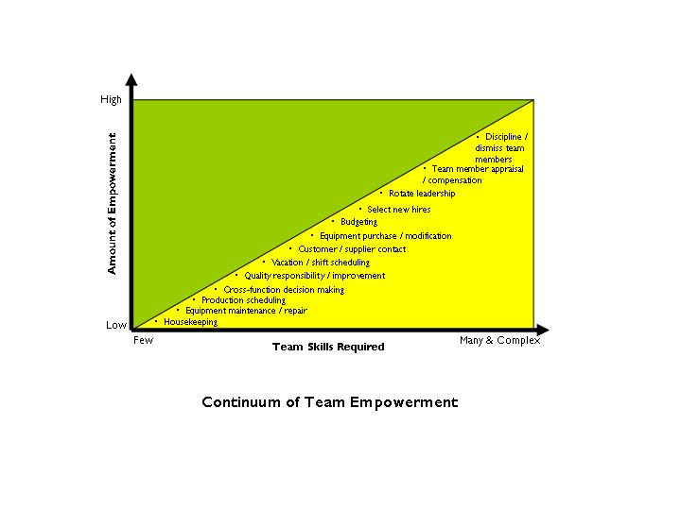
Below are three examples of empowerment introduced at team level.

Overcoming the silo mentality (Chrysler)

Chrysler was considered a moribund car manufacturer for much of the 1980s, yet during the 1990s the company experienced something of a rebirth.

Much of the credit for this turnaround has to go to the new speed with which Chrysler was suddenly able to take a product from initial concept to market launch. For a while in the 1990s, Chrysler had the shortest “time to market” of any major car manufacturer in the world.

The secret? A team-working concept known as “tear down the walls” which involved designers, project managers and production team members working together for the duration of a project. “Together” meant in the same room, on the same tasks, at the same time. Despite its simplicity, this was a revolutionary concept in an industry where rigid demarcation often meant that production wouldn’t see a car design until it was finished.

Vice Chairman Robert Lutz describes how things used to be in the following terms:

“Most departments were in separate buildings, insulated by bricks and mortar. Our designers worked pretty much in a vacuum, conceiving a product and `throwing it over the wall’ to engineering in the next building. They would do the same to procurement, and supply, and so on down the line.” With this way of working, product development was slow and sequential, with frequent miscommunication, false starts, errors and waste. “There was no simultaneous contact, no exchange of ideas, no trade-offs occurring early in the program”.

The “tear down the walls” approach involved designing work around the flow of information. Design decisions are made collectively, as early as possible, and at the lowest possible level in the organisation. Senior managers at Chrysler now have two distinct job titles: one functional and one cross functional. For instance, the Head of the Jeep/Truck platform team is also Vice President of Engineering Technologies. Lutz believes that “this natural check-and-balance system keeps the focus on the whole, rather than on pieces of the whole.” This may be the reason why other major manufacturers were so swift to adopt Chrysler’s platform team model.

Empowering the team (P&O Stena Line Call Centre)

The past few years have been turbulent for P&O Stena Line. Hard on the heels of the Channel Tunnel’s opening came the merger between P&O European Ferries and Stena Sealink, followed shortly by the phasing out of Duty Free. Much of the credit for the company’s strong sales and customer satisfaction performance over this time goes to its highly successful Reservations team, established during the same period.

From the start, there was a determination that Reservations would be different from the rest of the organisation. A visit to the call centre reveals many features at odds with the “command and control” culture of a long-established shipping company:

- There are totem poles and other Red Indian paraphernalia, denoting the team’s warring tribes
- A “chill out” room, fringed with palm trees, offers cable television, music, refreshments, or just somewhere to get away from the pressure of the sales floor

Posted prominently in several places are the team’s shared values:
- Innovation
- Teamwork
- Trust
- Respect
- Integrity

There is much evidence that achievement and success are recognised – photographs of employee of the month award winners, chocolates for going beyond the call of duty, take-away orders for those doing over-time.

These and many of the team’s other innovations, have been devised and introduced by team members – the extensive team intranet has been gradually built by Reservations people with no previous experience; most training is designed and delivered by members of the team.

The separate path pursued by Reservations has not been universally well received –complaints about elitism and favourable treatment have been frequent, provoked by instances such as the discovery that staff toilets in Reservations have luxury soap and soft towels!

But the team’s success has been widely recognised, with some prestigious awards for innovation and high performance in call centre management. It is particularly interesting that the rest of P&O Steno Line has begun to follow the line of its highest performing team: new statements of corporate vision and values have been developed, and a programme of transformational leadership is being delivered for all managers.

A self-managed team (Benefits Agency)

Two events triggered the establishment of a self-managed information team in a North West Benefits Agency office:
- A successful training programme on empowerment attended by many managers and staff

- The departure of the team’s supervisor.

The information team consisted of eight women, working part-time. Between them they were handling over 4000 enquiries a month on matters such as Disability Allowances and Maternity Benefit.

There was surprisingly little direction when the self-management approach was introduced. Most attention was focused on ensuring that team members had a senior figure to support them if they hit trouble, and a Boundary Manager was appointed who agreed to be available to the team if needed.

As the new arrangement developed, team members quickly realised that:
They needed to identify functional specialisms, rather than all doing essentially the same job (as they had in the past)
With no supervisor, everybody’s working knowledge had to improve, to ensure efficient service to callers.

It didn’t take long before, accustomed to their greater autonomy, team members began to initiate process improvements such as:

- Enquiry analysis
- Building a knowledge database, with information from areas outside the team’s usual remit (e.g. Income Support)
- Introducing a customer satisfaction survey.

A significant difficulty for this team of part-timers was ensuring effective collaboration and communication, without a co-ordinating supervisor. This might have undermined collective confidence in the new team approach, but with the timely introduction of new processes (such as a Communications Book) the team was able to maintain momentum. Three measures of the team’s success after its first year were:

- The reduction in enquiries (this was their major goal)
- The gradual withdrawal of the Boundary Manager – who reduced contact time to half an hour every four weeks, plus six monthly performance review meetings for each individual
- The fact that the rest of their Department has since introduced “empowered teaming” on a wider basis.

