LOAN MARKET ASSOCIATION (LMA)

The Loan Market Association (LMA) is Europe's trade association for the syndicated loan markets. It is stated to be the authoritative voice of the syndicated loan market in EMEA, we work with lenders, law firms, borrowers and regulators to educate the market about the benefits of the syndicated loan product, and to remove barriers to entry for new participants. Its core activities are:
(1) Provision of recommended documentation for both primary and secondary syndicated loan markets;
(2) Establishing market practice;
(3) A wide range of education and training events throughout Europe and the Middle East;
(4) Collective lobbying; and
(5) Networking opportunities.
The LMA's office is located in London although the Association is active throughout the Euroloan region. Events are held in major Western European financial centres, Central and Eastern Europe, Skandinavia and the Middle East.
The LMA was established in 1996. It has a corporate membership of over 850 member organisations from over 65 countries comprising banks, institutional investors, law firms, rating agencies and system providers, all actively engaged in the international syndicated loan markets.
The LMA works in five main areas: documentation, market practice and guidance, loan operations, education, and dialogue with legislators and regulators.
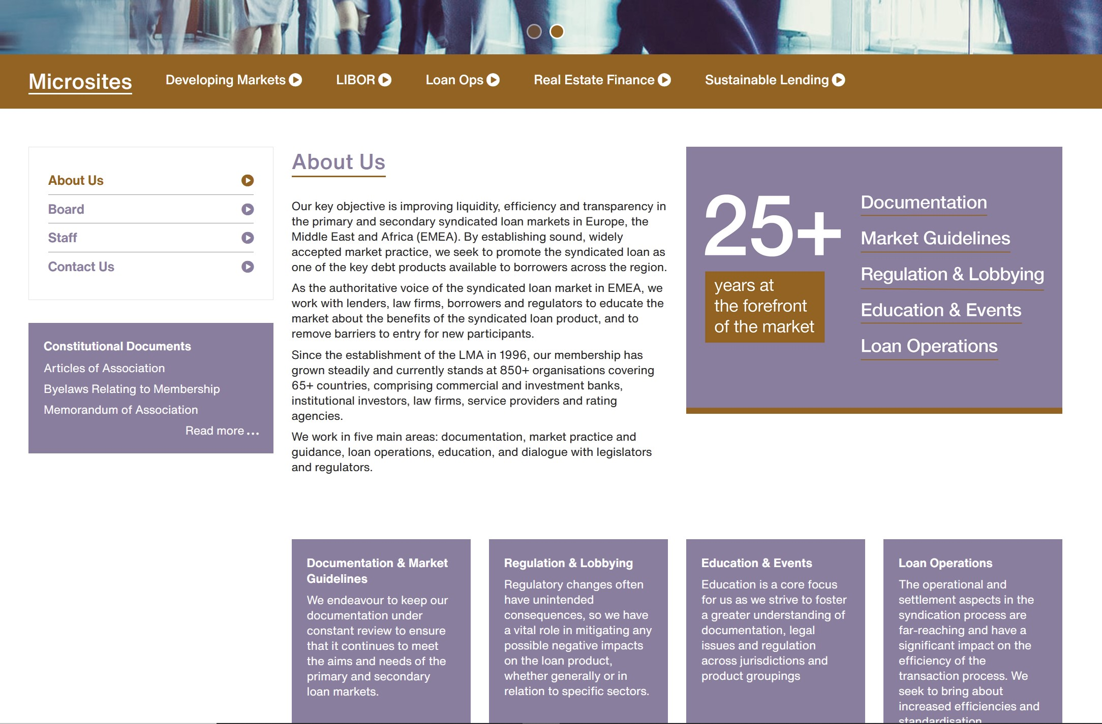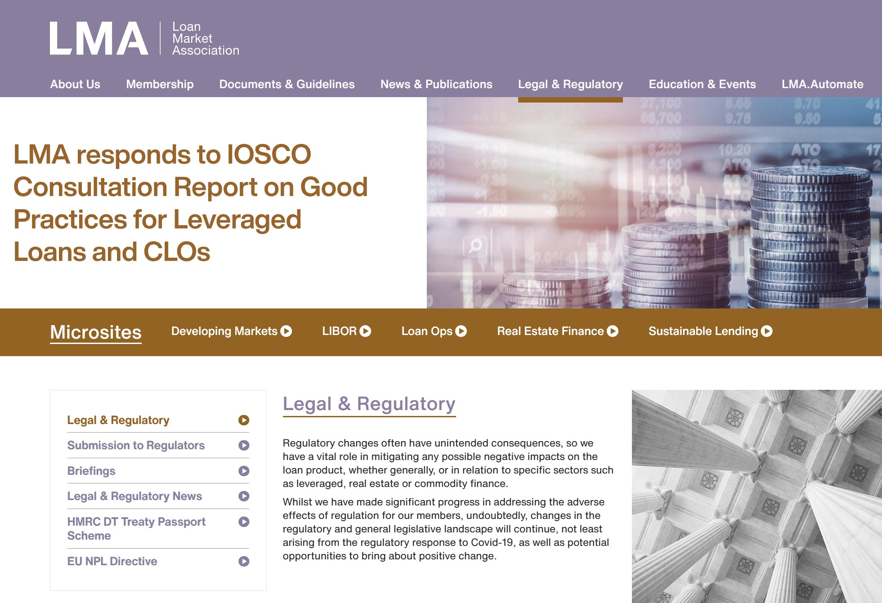

ADVANTAGES
- More efficient execution of primary and secondary loan business
- Increased liquidity in both primary and secondary loan markets
- Ability to manage loan portfolios more efficiently and effectively
- Reduced costs by virtue of a collective approach to issues
- Timely exchange of views and circulation of topical information
- Dedicated website for accessing recommended form documents
- Education and training courses for members
- Opportunity to participate in addressing issues and solving problems

COMMITTEE STRUCTURE
- Agency - members are loan agency practitioners. The committee aims to address issues that may impact on agency departments and to recommend best practice.
- Distressed Debt - the committee is made up of market practioners and lawyers and reviews existing LMA documentation to ensure its ongoing applicability as well as considering recommended best practice.
- Documentation - the committee is made up of market practioners and lawyers actively involved in developing new primary market documents and revising existing ones for changes in law, regulation and market practices.
- Loan Operations - the aim of the committee is to identify the market's key requirements relating to automating aspects of the settlement/loan operation processes.
- Par Trading Practices - members are secondary par loan market participants and the committee focuses on addressing the issues faced by that market, such as documentation and best practice.
- Tax - the committee identifies and tackles problems faced by syndicated loan practitioners throughout the Eurozone and reviews LMA documentation for tax issues.
In addition, the Board and committees establish Working Parties to address specific issues and projects.

FAQ's
- What are the criteria for membership?
There are two types of membership: Full and Associate. Full members must be financial institutions and are likely to be loan arrangers, traders and other active participants in the loan market. Associate members are likely to be rating agencies, law firms, accountancy firms, smaller financial institutions and other professionals with an interest in the market. Membership is not open to individuals. For details regarding subscription costs and benefits of membership, please look at 'Subscriptions' or call us on +44 (0) 20 7006 6007.
- My firm is interested in becoming a member but it's now the middle of the year. Are subscription fees pro-rata ?
No. Membership lasts from 1 January to 31 December of each year and the full year's subscription fee must be paid whenever your institution joins. If you are still interested in becoming a member but you would rather wait until the start of the following year, we will be happy to take a note of your details and send out some documentation closer to the end of the year.
- Is the LMA documentation available for purchase by non-members?
The LMA Primary Market documents are available for sale to academic/training organisations. For more information on this contact lma@lma.eu.com. Otherwise LMA documents are available to members only.
- What is the LMA's connection with Clifford Chance?
Clifford Chance is a member of the LMA and acts as the LMA's legal counsel. The LMA has its office located in the Clifford Chance building, but is an independent UK registered company.
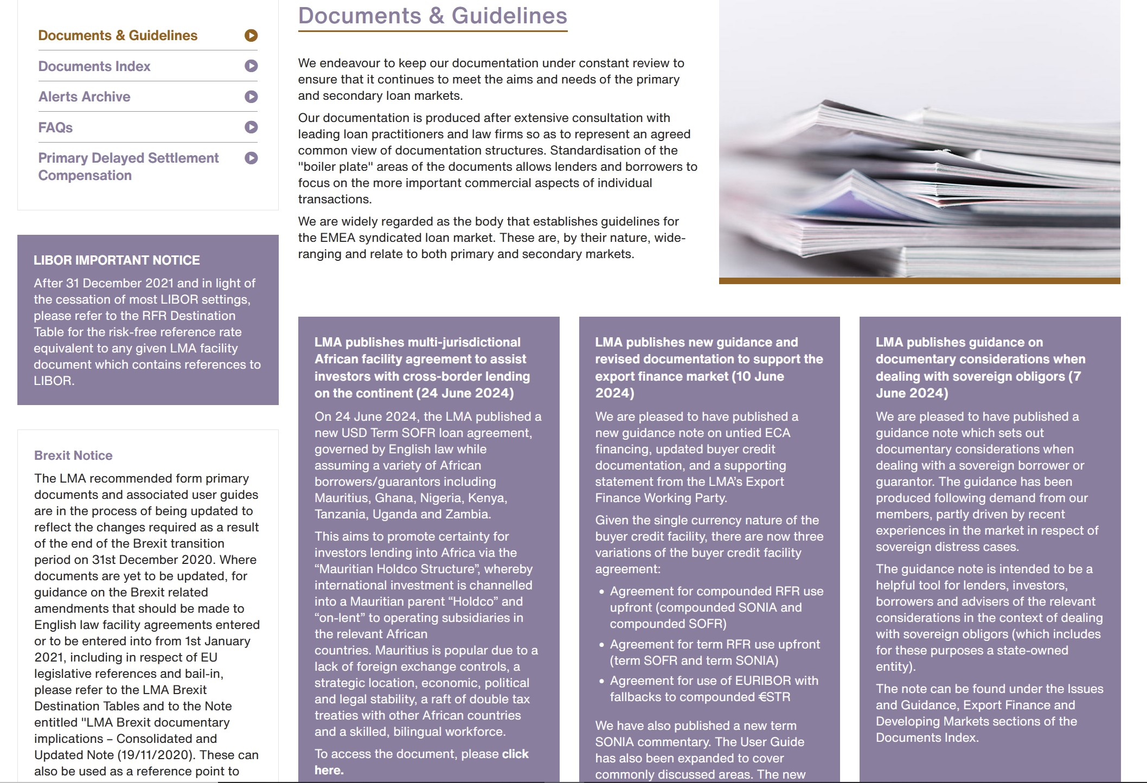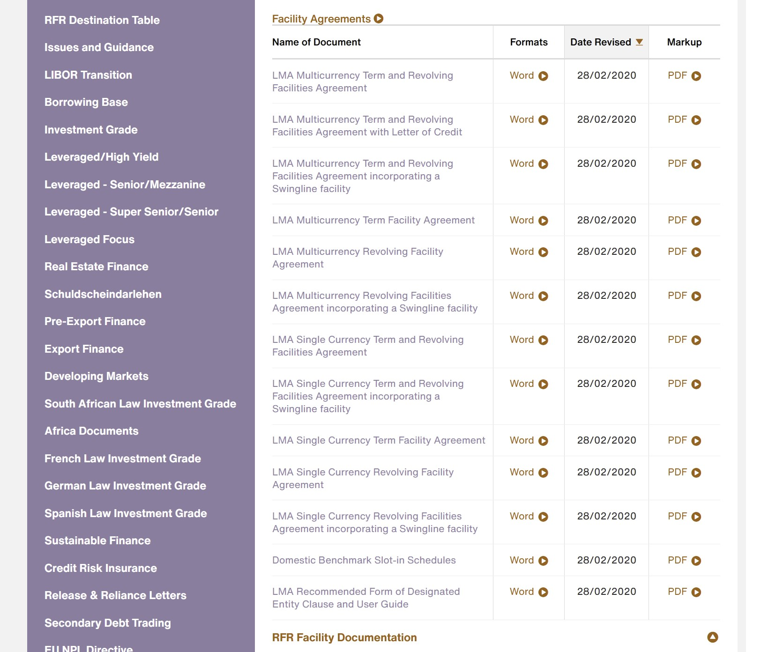

RECOMMENDED DOCUMENTS
There are fourteen sub-headings under the Documentation area of the web site - available to members only. The following is a list of all the documents published by the Loan Market Association.
Documents are available for downloading to Members only within the Members Area

These Materials (which term includes, where the context permits, text, content, spreadsheets incorporating macros and electronic interfaces, and their underlying assumptions, conversions, formulae, algorithms, calculations and other mathematical and financial techniques) are made available to members of the Loan Market Association to facilitate the documentation of transactions in the loan markets. None of the Loan Market Association, Allen & Overy or Clifford Chance accept any responsibility for any use to which these Materials may be put or for any loss, damage or liability whatsoever arising from such use. None of the Loan Market Association, Allen & Overy or Clifford Chance has reviewed the laws of any jurisdiction which may apply to either party to an agreement using these Materials and its subject matter. Members should therefore consider all the relevant legal, accounting and regulatory issues before using these Materials or entering into a transaction under them and, if appropriate, consult their professional advisers.
In relation to recommended form documents, members are responsible for ensuring that the precise form and content of the documentation for a particular transaction is appropriate. Members should therefore satisfy themselves that the documents and any modifications to them are appropriate in the circumstances and the economic intentions of the parties.
The recommended form of syndicated facility agreements, the optional wording to be inserted into the Facility Agreements and the Syndication and Amendment Agreement, which are located within documents "Primary (Investment Grade)", have been produced with the involvement of The Association of Corporate Treasurers and the British Bankers' Association (neither of which accepts any responsibility for any use to which these documents may be put or for any loss, damage or liability whatsoever arising from such use). Neither The Association of Corporate Treasurers nor the British Bankers' Association has been involved in the development of any of the other standard forms.
The Loan Market Association consents to the use, reproduction and transmission of these Materials by members of the Loan Market Association only for the preparation and documentation of agreements relating to transactions or potential transactions in the loan markets. The Loan Market Association does not consent to the use, reproduction or transmission of these Materials for any other purpose, in any other manner or by any other person and expressly reserves all other rights.
In relation to the use of the Breakfunding Calculator (the "Calculator") whilst the Loan Market Association has taken reasonable skill and care to ensure that, when used correctly, the Calculator produces accurate guidance as to breakfunding costs, the Loan Market Association makes no representation or guarantee that information obtained from use of the Calculator will be complete, accurate or reliable. Results are provided without any warranty of any kind, express or implied. The proper working of the Calculator is reliant upon the correct input by users of information into all fields necessary to produce results. Failure by a user to input information fully and correctly is likely to lead to incorrect or misleading results produced by the Calculator, for which the Loan Market Association will not be responsible.

LMA DEVELOPMENT

June 2008 - First conference and training programme in Moscow
- April 2008 - First documentation training programme in New York
- October 2007 - Loan Operations Committee established
- September 2007 - German Law investment grade facility agreement launched
- April 2007 - First New York Conference
- March 2007 - Islamic Finance Users Guide launched
- November 2006 - 10th anniversary of LMA formation
- November 2006 - Training extended to the Middle East market
- October 2006 - Financial Covenants definitions published
- March 2006 - Training on LMA distressed trading documents introduced
- November 2005 - Training on LMA par trading documents introduced
- October 2005 - Revised LMA distressed debt documents launched
- May 2005 - First LMA Certificate Course
- January 2005 - Training on LMA leveraged document introduced
- September 2004 - LMA seminars extended to European locations
- April 2004 - Agency Committee established
- January 2004 - Leveraged loan primary document launched
- October 2003 - Training on LMA investment grade documents introduced
- July 2003 - Membership exceeds 200
- May 2003 - Mark-to-Market service for members launched
- July 2002 - French law/English language primary document launched
- April 2002 - Institutional Investor Committee established
- January 2002 - Web-based Breakfunding Calculator launched
- June 2001 - Guidelines on loan transferability issued
- February 2001 - Web-based Loan Pricing Calculator launched
- November 2000 - Lobbying: UK Treasury announces intention to amend regulations on interest payments to corporates
- March 2000 - Lobbying: UK Treasury allows interest relief on ratchet loans
- November 1999 - Investment Grade Primary Syndicated Loan Document launched
- June 1999 - First LMA Conference (Frankfurt)
- March 1999 - Distressed Debt Trading Documents launched
- June 1998 - Membership exceeds 100
- September 1997 - Secondary Trading Documents (Par/Near Par) introduced
- November 1996 - Loan Market Association formed with seven original members
ss
LMA DOCUMENTATION
Primary (Investment Grade)
LMA Multicurrency Revolving Facility Agreement
LMA Single Currency Term and Revolving Facilities Agreement
LMA Single Currency Term Facility Agreement
LMA Letter of Credit Option
LMA Mandate Letter - Underwritten
LMA Mandate Letter - Best Efforts
LMA Front Running Letter of Undertaking
Users Guide to Investment Grade Primary documentation
LMA Syndication and Amendment Agreement
LMA Single Currency Revolving Facility Agreement
LMA Recommended Mandatory Costs
LMA Syndicate Member Commitment Letter for Primary Syndication - for initial commitment without approval of documentation
LMA Syndicate Member Commitment Letter For Primary Syndication - for final commitment with approval of documentation
Explanatory Memo Relating To Mandate Letters, Commitment Letters, Front Running Letters, Syndication Closing Timeline & Syndication Decision Charts
Syndication Closing Timeline
Syndication Decision Chart - Unsuccessful Syndication
Syndication Decision Chart - Successful Syndication
LMA Confidentiality and Front Running Letter for Primary Syndication
LMA Multicurrency Term and Revolving Facilities Agreement
LMA Multicurrency term Facility Agreement
LMA US Dollar Swingline Option
LMA Euro Swingline Option
LMA Term Sheet
LMA Front Running Letter of Undertaking Users Guide
Primary (Leveraged)
Explanatory Memo on 2008 revisions to leveraged documents
Users Guide to Form of Facility Agreement for Leveraged Finance Transactions
Leveraged Term Sheet
Rider permitting disclosure to numbering service providers and administration/settlement service providers
LMA Confidentiality and Front Running Letter for Primary Syndication
LMA Front Running Letter of Undertaking
Form of letter re permission to disclose information to numbering service providers and administration/settlement service providers
Senior Multicurrency Term and Revolving Facilities Agreement
LMA Recommended Mandatory Costs
LMA Mandate Letter - Underwritten
LMA Mandate Letter - Best Efforts
LMA Syndicate Member Commitment Letter For Primary Syndication - for final commitment with approval of documentation
LMA Syndicate Member Commitment Letter for Primary Syndication - for initial commitment without approval of documentation
Syndication Closing Timeline
Syndication Decision Chart - Unsuccessful Syndication
Syndication Decision Chart - Successful Syndication
Explanatory Memo Relating To Mandate Letters, Commitment Letters, Front Running Letters, Syndication Closing Timeline & Syndication Decision Charts
Financial Covenants Provisions
Financial Covenants Provisions Users Guide
LMA Front Running Letter of Undertaking Users Guide
Sec Debt Trading (Par)
Explanatory Memo on the 2008 revisions to the LMA Confidentiality Letters
LMA Master Funded Participation Agreement (Par)
LMA Master Risk Participation Agreement (Par)
LMA Transfer Agreement (Par)
LMA Confidentiality Letter (Seller)
LMA Confidentiality Letter (Purchaser)
LMA Master Confidentiality Undertaking
LMA Settlement Letter
Users Guide to Secondary Debt Trading (Par)
LMA Grantor Credit Risk Paper
LMA Standard Terms and Conditions for Par Trade Transactions
LMA Termination and Transfer Agreement (Novation) (Par)
LMA Transfer Certificate (Par)
Confidentiality Letter (Seller's Agent/Broker)
Confidentiality Letter (Purchaser's Agent/Broker)
LMA Funded Participation (Par)
LMA Risk Participation (Par)
LMA Master Confidentiality Undertaking for use with Administration/Settlement Services Providers
LMA Trade Confirmation (Par)
LMA Funded/Risk Participation (Par)
LMA Risk to Funded Participation
LMA Assignment (Par)
LMA Optional Clause (Call Option)
LMA Optional Clause (Put Option)
Users Guide to Settlement Letter for Par Trades
Schedule/Breakfunding Calculator for use with Settlement Letter for Par Trades
Code of Practice
Consultation Panel Guidelines
Glossary of Terms for Transfers of Interests in Loans
Sec Debt Trading (Distressed)
Termination and Transfer Agreement (Novation) (Distressed)
LMA Standard Terms and Conditions (bank debt/claims)
LMA Funded Participation (Distressed)
LMA Assignment (distressed bank debt)
Users Guide to LMA Distressed Debt documentation
LMA Assignment (distressed/calims)
LMA Transfer Agreement (distressed)
Memo explaining latest revisions to documentation
LMA Trade Confirmation (distressed/bank debt)
LMA Standard Terms and Conditions (bank debt/claims)
Standard Representations and Warranties (bank debt/original lender of record)
Standard Representations and Warranties (bank debt/secondary lender)
LMA Standard Representations and Warranties (claims/original holder)
LMA Standard Representations and Warranties for Distressed Debt Trade Transactions (claims/secondary holder)
Mandatory Costs
LMA Mandatory Costs - A Recommendation (Update)
Grey Market
LMA Confidentiality and Front Running Letter for Primary Syndication
LMA Front Running Letter of Undertaking
LMA Front Running Letter of Undertaking Users Guide
French Law Primary
LMA Multicurrency Term and Revolving Facilities Agreement
User Guide to Multicurrency Term and Revolving Facilities Agreement
LMA Multicurrency Term and Revolving Facilities Agreement (French Translation)
German Law Primary
Multicurrency Term and Revolving Facility Agreement
Users Guide
Islamic Finance Users Guide
Users Guide to Islamic Finance Documents
Glossary of Terms
Glossary of Terms for Transfers of Interests in Loans
Non-Public Information Papers
Private and Inside Information in the Loan Market
Joint Trade Associations paper on Non-Public Information
Dealing with confidential and price sensitive information
JMPF European Supplement
US JMPF Paper Oct 2003
Competition Law Papers
Key competition law areas of awareness
Coordination Committee Letters
Form of Letter to Parent governing appointment of Coordinator and Coordinating Committee
Form of Letter to Lenders governing the appointment of Coordinator and Coordinating Committee
LMA guidance notes on role of coordinator and coordinating committee
Mark-Ups
Mark up of German law Multicurrency Term and Revolving Facility Agreement
Mark up of French Law LMA Multicurrency Term and Revolving Facilities Agreement
Mark up of French Law LMA Multicurrency Term and Revolving Facilities Agreement (French Translation)
Mark-up of Mandatory Costs Recommendation
Leveraged Facilities Agreement
Users Guide to the LMA form of Leveraged Facilities Agreement
Financial Covenants Provisions
Standard Terms and Conditions for Par Trade Transactions
Transfer Agreement (Par)
Assignment (Par)
Confidentiality Letter (Seller)
Confidentiality Letter (Purchaser)
Master Confidentiality Undertaking
Funded Participation (Par)
Risk Participation (Par)
Funded/Risk Participation (Par)
Risk to Funded Participation (Par)
Master Funded Participation Agreement (Par)
Master Risk Participation Agreement (Par)
Funded Participation (Distressed)
Users Guide to Secondary Debt Trading Documentation (Par)
Users Guide to Distressed Debt Documentation
Leveraged Term Sheet
Rider permitting disclosure to numbering service providers and administration/settlement service providers
German version of Multicurrency Term and Revolving Facility Agreement
LMA Standard terms and Conditions for Par Trade Transactions
LMA Termination and Transfer Agreement (Novation) Par
LMA Transfer Certificate (Par)
Confidentiality Letter (Seller's Agent/Broker)
Confidentiality Letter (Purchaser's Agent/Broker)
LMA Funded Participation (Par)
LMA Risk Participation (Par)
LMA Master Confidentiality Undertaking for use with Administration/Settlement Services Providers
LMA Funded/Risk Participation (Par)
LMA Risk to Funded Participation
LMA Master Funded Participation Agreement (Par)
LMA Master Risk Participation Agreement (Par)
LMA Assignment (Par)
LMA Transfer Agreement (Par)
LMA Confidentiality Letter (Seller)
LMA Confidentiality Letter (Purchaser)
LMA Master Confidentiality Undertaking
LMA Settlement Letter
Termination and Transfer Agreement (Novation) (Distressed)
LMA Standard Terms and Conditions (bank debt/claims)
LMA Assignment (distressed bank debt)
LMA Assignment (distressed/claims)
LMA Transfer Agreement (distressed)
LMA Funded Participation (distressed)
Users Guide to LMA Distressed Debt documentation
LMA Confidentiality and Front Running Letter for Primary Syndication
LMA Syndication and Amendment Agreement
LMA Letter of Credit Option
LMA Mandate Letter - Underwritten
LMA Mandate Letter - Best Efforts
LMA Letter of Undertaking
Users Guide to recommended form of Primary Documents
LMA Single Currency Revolving Facility Agreement
LMA Single Currency Term Facility Agreement
Form of letter re permission to disclose information to numbering service providers and administration/settlement service providers
Form of Letter to Parent governing appointment of Coordinator and Coordinating Committee
Form of Letter to Lenders governing the appointment of Coordinator and Coordinating Committee
LMA Front Running Letter of Undertaking Users Guide
LMA Front Running Letter Of Undertaking User Guide
Intercreditor Agreement
LMA Intercreditor Agreement
LMA Intercreditor User Guide

